**1. Research Background**

The Named Entity Recognition (NER) task extracts chunks of text from a sentence and classifies them into pre-defined categories such as the names of persons, locations, and organizations.

NER systems have been created that use linguistic grammar-based techniques as well as statistical models such as machine learning.[1] Hand-crafted grammar-based systems typically achieve better precision, but at the cost of lower recall and months of work by experienced computational linguists.[2] Statistical NER systems typically require a large amount of manually annotated training data.

Because of efficiency considerations, we choose linguistic grammar-based techniques to train the model, and the most common model is LSTM-CRF networks.[3] This network can efficiently use past input features via a LSTM layer and sentence level tag information via a CRF layer. With such a CRF layer, we can efficiently use past and future tags to predict the current tag.

**2.Project Objective:**

The purpose of the project is to develop a NER algorithm based on an existing algorithm trained initially on an existing dataset to tackle the recognition problem for a given specific domain dataset with greater accuracy. The NER algorithm tries to label name entities like a person, organization, location, and so on.

**3.Research Methods:**

3.1 Implementing existing algorithm

3.2 Training existing algorithm on an existing dataset

3.3 Running existing algorithm on the given specific domain dataset

3.4 Analysis of errors

Data cleaning and labeling.

3.2 Compare with existing algorithm.

**4.Project Process**

4.1Based on the recognition result of Stanford CoreNLP, we analyse the mistakes when the existing Name Entity Recognition tools process the given dataset for a specific domain and, from the analysis, determine the research direction to take going forward.

4.1.1We build the Stanford CoreNLP environment and train the Stanford Name Entity Recognizer with the CoNLL-2003 dataset, which is a public and common dataset. Then, we use the trained model to process the dataset X, which is the given dataset of a specific domain.

4.1.2 From an analysis previously done on the recognition results using the Stanford Name Entity Recognizer on dataset X, it was found that wrong input format (e.g. “RMB51 ,453” will be recognized as “RMB51” and “453”), long organization name (e.g. “The Institute of Chartered Secretaries and Administrators” will be recognized as “The Institute of Chartered Secretaries”) and mixed Chinese text (e.g. the Chinese name entity will not be recognized in a long English sentence) would result in a wrong recognition.

4.1.3 Based on the existing NER algorithm and dataset, we plan to improve the performance of the recognition result in 2 ways: First, we can adjust the training dataset to make it more suitable for the Name Entity Recognition algorithm for the specific domain dataset recognition. Second, we can adjust the classic LSTM-CRF algorithm by combining the existing algorithm to improve the performance.

4.2 Adjust the training dataset to improve the algorithm performance.

4.2.1 We clean the existing specific field dataset to repair the wrongly-formated data and remove mixed Chinese text.

4.2.2 We label the existing specific domain dataset using IOBES tagging scheme.

4.2.3 To find out if the dataset improves the performance of the algorithm, we train the algorithms with both the CoNLL-2003 dataset and the specific domain dataset. In addition, to get better performance, we can adjust the training dataset’s format and scale.

4.3 Adjust the classic LSTM-CRF algorithm

4.3.1 Compared with the Stanford CoreNLP Name Entity Recognizer which is based on CRF Classifier, we build the LSTM-CRF model to get better performance when processing the sequence input data.

4.3.2 We adjust the structure of the LSTM-CRF model by combining the existing algorithm to improve the recognition performance.

[add rare word recognition]

**5. Project flow chart**

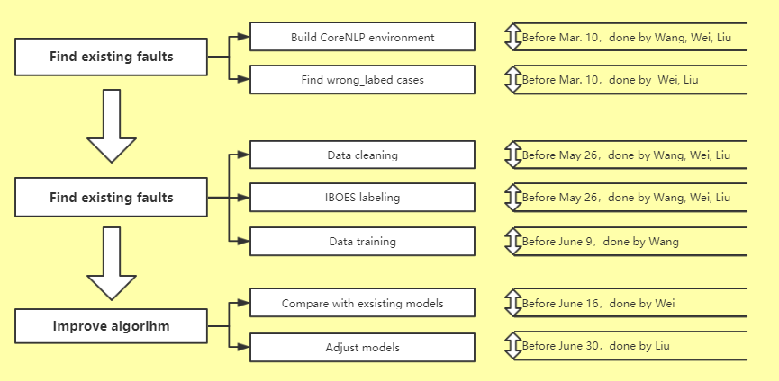

**6. Division of labor**



1. Cite reference
2. Cite reference
3. Cite reference